Nexora events and bookings
Document 12 of the Nexora learning guides
Source snapshot 14 October 2026 at 06:41 UTC
Understand event offerings, sessions, capacity, registrations and attendance.

Recognise the screen and its scope
Open /events/events, /events/events/[id]. CRM routes use port 3017; member routes use 3018; public website routes can use 3019. Brackets name a route parameter, not text to paste into a browser. Choose a real record or site id from the application.
This guide covers Event creation; Venue and dates; Sessions; Contact bookings and waitlists; Attendance transfer promotion and cancellation; Activity history.
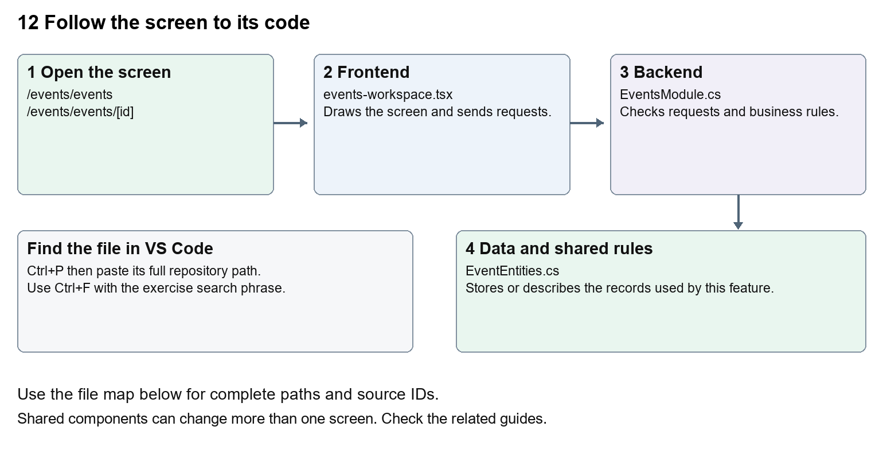
The diagram shows the file roles. The full paths below are what you paste into Ctrl+P.

Find the files in VS Code
Role | File and source ID | What it does
Screen | S0097 events-workspace.tsx | Main UI or route for this topic
Server | S0329 EventsModule.cs | Endpoints or server rules
Data | S0328 EventEntities.cs | Data shape or persistence structure

Screen S0097
apps/web/src/features/events/events-workspace.tsx
Server S0329
backend/src/Modules/Nexora.Modules.Events/EventsModule.cs
Data S0328
backend/src/Modules/Nexora.Modules.Events/Domain/EventEntities.cs
The complete HTML manual opens these source IDs inside its Source library. The Word manual shows short labelled extracts so you can learn the flow before reading large files. Each individual Markdown guide includes its complete primary files after the walkthrough.

Follow the request and the records
1. The events route sets offeringKind to event.
2. The workspace lists /api/v1/events/offerings.
3. A create form supplies dates, venue and capacity.
4. Selecting a Contact creates an enrollment or waitlist entry.
5. The backend validates dates, capacity and permitted booking transitions.

Read the code with an explanation
Events, courses and exams share Offering and Enrollment structures. The kind selects which behaviour and wording apply. Dates entered by the browser are converted to UTC for requests. An enrollment is the participant's booking; an Offering is the thing they attend. Server capacity checks remain necessary when several people book at once.
Source reference S0097 apps/web/src/features/events/events-workspace.tsx
Selected opening lines with their original numbers. The complete file is in the HTML source library.
0001 "use client";
0002 import { RecordListing } from "../shared/record-listing";
0003 import listingStyles from "../crm/record-listing.module.css";
0004 import { WorkspaceHeading } from "@/components/ui/workspace-heading";
0005 import { useRouter } from "next/navigation";
0006 import type { Route } from "next";

The import lines lead to shared components and helpers. Start at the exported component or route function; follow the request helper to the server rather than assuming the whole feature lives in this file.
Source reference S0329 backend/src/Modules/Nexora.Modules.Events/EventsModule.cs
Extract from source line 27. A fragment from a long line is shown without the rest of that line.
0027 api.MapGet("/contacts",(string? search,ICrmDirectory crm,CancellationToken ct)=>crm.SearchContactsAsync(search,ct));

On the server, look for MapGet to load records, MapPost to create or perform an action, MapPut or MapPatch to change data, and RequireAuthorization for permissions. Some shared methods register endpoints indirectly. Find SaveChangesAsync to see the database write. A request method alone does not tell you every side effect.
Source reference S0328 backend/src/Modules/Nexora.Modules.Events/Domain/EventEntities.cs
Selected opening lines with their original numbers. The complete file is in the HTML source library.
0001 using Nexora.BuildingBlocks.Domain;
0002 namespace Nexora.Modules.Events.Domain;
0003 public sealed class Offering : TenantEntity
0004 {
0005 public string Kind { get; set; } = "event";
0006 public string Name { get; set; } = "";

Follow model fields to their request names and database mapping. An id points to a particular record. A tenant id limits the organisation. A version or concurrency stamp protects newer edits. Some model files describe contracts rather than tables; check the owning DbContext before assuming storage.

Make or trace your first change
1. Press Ctrl+P and open apps/web/src/features/events/events-workspace.tsx.
2. Press Ctrl+F and search for Venue or online location. In this snapshot it appears at line 28.
3. Replace only this form label. Open the event create form and verify dates and capacity remain present. Because the component is shared, also inspect a course form.
4. Replace only Venue or online location with Venue or meeting link in that intended location. Keep quotes, tags, JSON keys and routes intact.
5. Save with Ctrl+S. Inspect Problems and the local screen. Review the diff and restore the original text when you finish practising.
Extract from source line 28. A fragment from a long line is shown without the rest of that line.
0028 n>)}</select></Field><Field label="Venue or online location"><input className={input} name="venue" maxLe

These exercises have not been applied to the application. Their search phrases are verified against the captured source. Line numbers can move; the phrase and file path are your main navigation aids.

Check a change and diagnose problems
Confirm the original screen still loads, the changed words appear in the intended place, and another screen using the same component still behaves correctly. If an action fails, inspect the browser Network response, the relevant helper and server validation message. Use the common error table at the beginning of the manual. Reload on a version conflict instead of removing the version check.
A syntax error after a text edit usually means a quote, brace or closing tag changed. Compare your diff with the original. An unchanged browser result can mean the wrong port, a saved published configuration overriding a default, or a running API that has not reloaded.

Understand the current limits
Stored registrations are not ticket-payment integration. Cancellation and transfer alter real attendance records; only use approved test data for business actions.

Continue learning
Related guides 13 Nexora courses and training, 14 Nexora examinations and results, 15 Nexora sales and finance.

